Observation JSON Format

Présentation

16/05/2022

Environmental Sensing

Table of Contents

1 Introduction 3

1.1 Conventions used 3

1.2 Terminology 3

1.3 Rules 3

2 Environmental Sensing – Observation 4

2.1 Principles 4

2.2 Data model 5

2.3 Type 5

3 ObsJSON objects 6

3.1 Observation 6

3.2 Attribute Member 7

3.2.1 ESId 7

3.2.2 ESName 7

3.3 Result Member 7

3.4 Feature Member 8

3.5 Index Members 9

3.5.1 ESOrder 9

3.5.2 ESCoupled 10

3.5.3 ESIndex 10

3.6 Data Member 11

3.6.1 ESInformation 11

3.6.2 ESParameter 12

3.6.3 ESUserData 12

4 ESValue 13

4.1 Structure 13

4.2 TypedValue 14

4.3 DatationValue 14

4.4 LocationValue 15

4.5 PropertyValue 16

4.6 NamedValue 17

4.7 ExternValue 17

5 Appendix: TypeCatalog 19

6 Appendix : reserved values 20

7 Appendix : Examples 21

8 Appendix : CBOR format 22

9 Appendix : Indexed list 24

# Introduction

ObsJSON is a text format for the ES-Observation data.

This format is an application of the JSON format (RFC 8259), GeoJSON format (RFC 7946), Date and Time format (RFC 3339).

A binary version is also defined (Appendix) with CBOR format (RFC 8949)

## Conventions used

The key words "MUST", "MUST NOT", "REQUIRED", "SHALL", "SHALL NOT", "SHOULD", "SHOULD NOT", "RECOMMENDED", "NOT RECOMMENDED", "MAY", and "OPTIONAL" in this document are to be interpreted as described in BCP14 [RFC2119] [RFC8174] when, and only when, they appear in all capitals, as shown here.

The grammatical rules in this document are to be interpreted as described in [RFC5234].

## Terminology

The terms Json-Text, Json-Value (Value), Object, Member, Array, Number, String, False, Null, True are define in the JSON grammar.

The terms Geometry-type, Point, MultiPoint, LineString, MultiLineString, Polygon, MultiPolygon, GeometryCollection, GeoJSON-Types are defined in GeoJSON grammar.

Timestamp is defined in Date and Time format.

## Rules

A Value in an ESValue SHOULD be unambiguous (i.e., parsers CAN deduce the Value type).

An ObsJSON-Text CAN contains all the ESObservation information (i.e., the ESObservation build from the ObsJSON-Text is identical to the initial ESObservation).

Values in Array are ordered and independent from the other Values.

Members in Objects are not ordered.

# Environmental Sensing – Observation

## Principles

The concept of "Observation" is defined in the ISO19156 Standard. It allows to represent for example:

* Unit data from sensors,
* Modeling results,
* Geographical distributions,
* 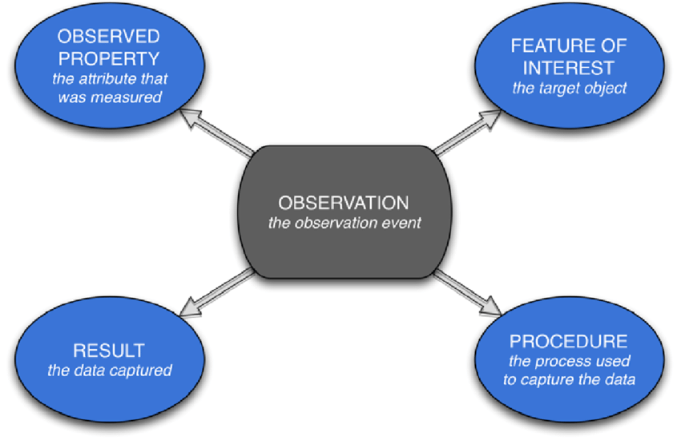Temporal or trip histories,

In this Standard, an Observation is characterized by:

* "Observed property": the observed property,
* "Feature of interest": the object (usually a place) of the observation,
* "Procedure": the information acquisition mode (sensor, model, etc.)
* "result": result of the observation or measurement

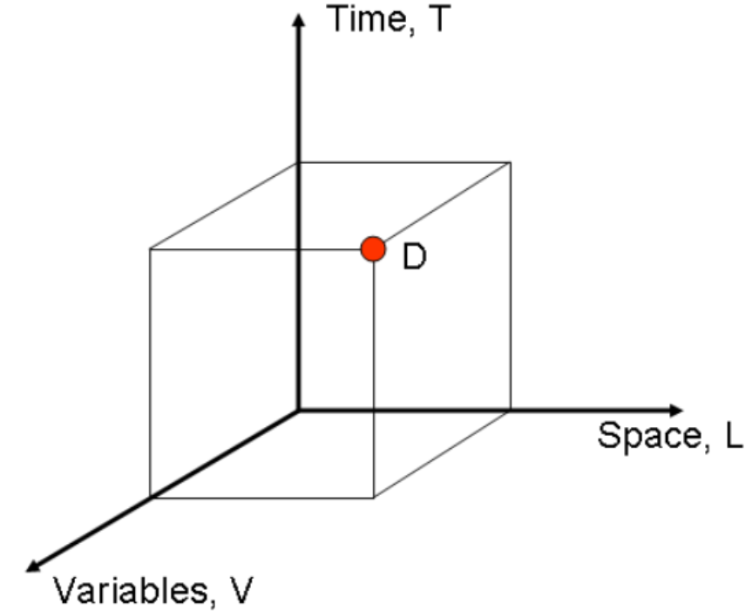

*CUAHSI Community Observations Data Model*

The result is a set of values referenced according to the 3 dimensions:

* Temporal,
* Spatial,
* Physical (observed property)

It can be converted into a 3-dimensional matrix, with each result indexed by temporal, spatial and physical values.

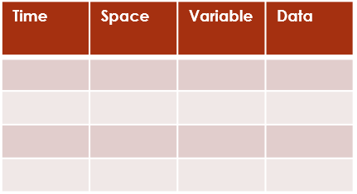

*interleaved*

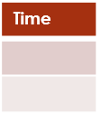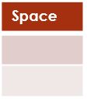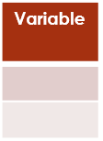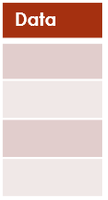

*domain-range*

*Note: This “domain range” indexed representation is preferred to an “interleaved” tabular representation which associates temporal, spatial, and physical values with each result value.*

Common properties (flags) are associated with each Observation. They make it possible to perform processing on the Observations without having to know their composition (e.g., bounding boxes, type of observation, volumetry, etc.).

*Note: If the indexed representation is identical to the original, the “domain range” representation is equivalent to the “interleaved” tabular representation.*

## Data model

An Observation is an Ilist Object (Result, Features and Index data - see Appendix).

The Features included in the Ilist Object are “named values” (see chapter 4 ESValue) with defined types: datation, location, properties but also “open types” (see chapter 4).

Other information completes the Ilist Object:

* Type
* Attributes (name, id)
* Data (user data, information data, parameter data)

## Type

The Type characterizes the nature of Observation and ESValue such as ‘datetime’, ‘Ilist’, ‘slot’.

The type is defined by a string.

# ObsJSON objects

## Observation

An ObsJSON is a JSON-text and represents an Observation.

ObsJSON is defined by a Type and consists of an object (ESObservation).

**Type :** “observation”

**Description**

The ESObservation Members are described in the figure below:

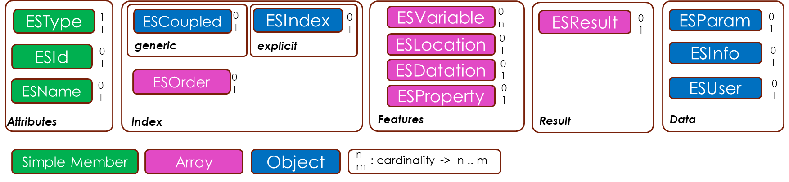

The Members are:

|  |  |  |  |
| --- | --- | --- | --- |
| Category | Member | Key | Value |
| Attributes | ESName | « name » | String |
| Attributes | Type | « type » | « observation » |
| Attributes | ESId | « id » | String |
| Result | ESResult | « result » | Array or ResultValue |
| Features | ESDatation | « datation » | Array or DatationValue |
| Features | ESLocation | « location » | Array or LocationValue |
| Features | ESProperty | « property » | Array or PropertyValue |
| Features | ESVariable | String | Array or Object |
| Index | ESIndex | « index » | Array or ESIdx |
| Index | ESCoupled | « coupled » | Object |
| Index | ESOrder | « order » | Array |
| Data | ESInformation | « information » | Object |
| Data | ESParameter | « parameter » | Object |
| Data | ESUserData | String | Object |

All those members are optional.

**Validity**

An ESObservation is valid if:

* it contains at least the Type Member,
* it contains at most one ESDatation, one ESLocation, one ESProperty, one ESResult Member
* each Member is valid.

**Example**

{“type”: “observation”, “datation”: “morning”, “location”: “paris”, “property”: “air quality”, “result”: “good”}

{“type”: “observation”, “datation”: “2021-01-05T22:18:26”, “location”: [2.4, 48.9], “property”: {“prp”: “PM10”, “unit”: “µg/m3”}, “result”: 51.3}

## Attribute Member

### ESId

**Description**

ESId is a single key/value Member:

* Key: “id”

The value is a string (e.g., Database Id or filename)

**Validity**

ESId is valid if key and value are as defined.

### ESName

**Description**

ESName is a single key/value Member:

* Key: “name”

The value is a string.

**Validity**

ESName is valid if key and value are as defined.

## Result Member

**Description**

Value of Result Member is an Array. Result is represented by an ESResult Member

|  |  |  |
| --- | --- | --- |
| Member | Key | Value |
| ESResult | « result » | Array of ESValue |

*Note:*

*If the Array contains only one value, the square brackets MAY be omitted in the JSON String.*

**Validity**

An ESResult Member is valid if:

* it contains at least one value
* each value is valid

**Example**

“result”: 21.5 *one NamedValue*

“result”: [21.5, [2.4, 48.9], {“valid value”: 43.3}, “high”] *four NamedValue*

## Feature Member

**Description**

Value of Feature Member is an Array. The Value Type is identical in an Array of defined Feature Member (ESDatation, ESLocation, ESProperty) or can be specific for each value of the Array (ESVariable):

|  |  |  |
| --- | --- | --- |
| Member | Key | Value |
| ESDatation | « datation » | Array of DatationValue |
| ESLocation | « location » | Array of LocationValue |
| ESProperty | « property » | Array of PropertyValue |
| ESVariable | String | Array of any ESValue |

*Note:*

*If the Array contains only one value, the square brackets MAY be omitted in the JSON String.*

*The key of ESVariable MUST be different from Reserved Names.*

**Validity**

An ESFeature Member is valid if:

* it contains at least one value
* each value is valid
* the Type of each value is consistent with the ESFeature

**Example**

“location”: “paris” *one LocationValue*

“location”: [[2.4, 48.9], [4.8, 45.8], [5.4, 43.3]] *three LocationValue*

“location”: [“paris”, “lyon”, “marseille”] *three LocationValue*

## Index Members

Several configurations are allowed:

|  |  |  |  |
| --- | --- | --- | --- |
| Configuration | ESOrder | ESCoupled | ESIndex |
| Complete ordered and not coupled | - | - | - |
| Complete ordered and coupled | - | X | - |
| Complete non ordered and coupled | X | X | - |
| Complete non ordered and not coupled | X | - | - |
| Non complete and ordered | - | - | X |
| Non complete and not ordered | X | - | X |

Complete: True if the Indexed List is complete (see Appendix)

Ordered: True if the order of Feature is the alphabetical order and if the Result name is ‘result’ or is after the Features (in the alphabetical order)

Coupled: True is at least two Features are coupled (see Appendix)

### ESOrder

**Description**

ESOrder define the order in ESIndex (explicit index form) or in Result (generic index form). ESOrder is a String Array.

The strings in the Array are the ESFeature keys ordered according to indexing.

If ESOrder is not present, the default value [“datation”, “location”, “property”, “first ESVariable key”] is used.

**Validity**

ESOrder is valid if:

* The values are present in ESFeature list,
* The length of the array equals the number of ESFeature.

**Example**

“order”: [“datation”, “property”, “location”}

### ESCoupled

**Description**

ESCoupled is used only with the “generic form”.

ESCoupled is an Object. The members are key/value and represent coupled ESFeature:

* Key: ESFeature key
* Value: ESFeature key

If no one ESFeature is coupled, ESCoupled is not present.

**Validity**

ESCoupled is valid if at least one member is present and if ESFeature keys are present in ESObservation.

**Example**

“coupled”: {“datation”: “location”} *datation and location are coupled*

### ESIndex

**Description**

ESIndex represent the “explicit form” of the index (see Indexed List Appendix)

It’s a two-dimensional array following the order defined in ESOrder:

* One row for each ESFeature,
* One column for each ResultValue

The values in Array are integer.

*Note:*

*If the ESObservation contains only one ESFeature, the square brackets for row MAY be omitted.*

*If the ESObservation contains only one ResultValue, the square brackets for column MAY be omitted.*

*If only one level of square brackets is present, the parser must decide if columns or rows are present*

**Validity**

An ESIndex Value is valid if:

* it contains at least one integer value
* the number of rows equals the number of ESFeature
* the number of columns equals the number of ResultValue
* the integer values are positive and lower than the length of ESFeature

**Example**

“index”: [[0,2,1], [0,0,0]] two ESFeature, three ResultValue

“index”: [0,2,1] one ESFeature, three ResultValue (or the opposite)

## Data Member

Data are Members where the Value MAY be an Object.

### ESInformation

**Description**

The Value of an ESInformation is an Object where Members are:

|  |  |  |
| --- | --- | --- |
| Member | Key | Value |
| ObservationType | « typeobs » | String |
| LocationType | « typeloc » | String |
| DatationType | « typedat » | String |
| PropertyType | « typeprp » | String |
| ResultType | « typeres » | String |
| nValLocation | « nvalloc » | Integer |
| nValDatation | « nvaldat » | Integer |
| nValProperty | « nvalprp » | Integer |
| nValResult | « nvalres » | Integer |
| BoundingBox | « bbox » | Array (4 Float) |
| IntervalBox | « tbox » | Array (2 String) |
| Complet | « complete » | True / false |
| Score | « score » | Integer |
| Rate | « rate » | Float |
| Dimension | « dimension » | Integer |
| Axes | « axes » | Array (1 to 3 integers) |

**Validity**

An ESInformation is valid if the Value contains at least one Member.

All the Value Members are optional.

**Example**

{"typeobs": "areaObsrecord"} *Minimal Value*

{"typeobs": "areaObsrecord", "complete": false, "score": 226} *Defined Member*

*Note:*

*That information come from the other ESObervation elements.*

*A parser MAY ignore The ESInformation Member to build an ESObservation.*

### ESParameter

**Description**

The Value of an ESParameter is an Object where Members are:

|  |  |  |
| --- | --- | --- |
| Member | Key | Value |
| Reference | « reference » | String |
| ResultTime | « resulttime » | Timestamp or DateTime |
| PropertyDict | « pdict » | String |
| UniqueIndex | « unicindex » | True/false |

**Validity**

An ESParameter is valid if the Value contains at least one Member.

All the Value Members are optional.

**Example**

{“unicindex”: true, “approbation”: true}

### ESUserData

The structure of ESUserData Member is totally free.

The keys used in ESUserData MUST be different from those defined in the Reserved list name (see Appendix.)

# ESValue

The ESValue are the Values included in the Feature or Result Arrays.

Five kinds of ESValue (one Type for each) are defined:

* DatationValue
* LocationValue
* PropertyValue
* NamedValue
* ExternValue

## Structure

**Description**

An ESValue is defined by a Type and a TypedValue which contains two information: A Name, a Value.

Two formats are used for ESValue:

* TypedValue format: TypedValue
* UntypedValue format: {Type: TypedValue}

The TypedValue format is used for ESDatation, ESLocation or ESProperty Features or with NamedValue.

The UntypedValue format is used for ESResult or ESVariable and not with NamedValue

**Validity**

An ESValue is valid if:

* One of the two formats is used,
* The TypedValue format is used in the defined cases
* The Type is a string present in the TypeCatalog (see Appendix)
* The TypedValue is valid for the Type
* each Value is valid compared to ESFeature

*Note:*

*If the ESValue is an Object and the key is not recognized as a valid Type, the TypedValue format is used.*

*If the ESValue is an Object and contains more than one Member, the TypedValue format is used.*

*If the ESValue is an Object, contains one Member and the key is a valid Type, the UntypedValue format is used.*

## TypedValue

**Description**

One of the three formats SHALL be used for TypedValue (where Name is a String):

* Name-Value format: {Name: Value}
* Value format: Value
* Name format: Name

**Validity**

A TypedValue is valid if:

* One of the three formats is used,
* it contains at least a Value or a Name
* each Value is valid compared to ESFeature

*Note:*

*The Name string MAY be used to represent:*

* *detailed information (e.g., “beginning of the observation”),*
* *link to external information (e.g., “*[*https://loco-philippe.github.io/ES.html*](https://loco-philippe.github.io/ES.html)*”),*
* *id to link internal information (e.g., “res003” where “res003” is a key in a ESData Object),*

*If the TypedValue is an Object and contains more than one Member, the Value Format is used.*

**Example**

“morning” *Name format*

{“morning”: “2021-01-05T10:00:00”} *Name-Value format*

[[“2021-01-05T08:00:00”, “2021-01-05T12:00:00”]] *Value format*

## DatationValue

**Type :** “datvalue”

**Description**

A Date is defined by a String Timestamp (as specified in RFC 3339).

The Value of a DatationValue is a representation of a single Date, an Interval (Array of two Dates) or a Slot (MultiInterval):

* Date: String
* Slot: Array of one or multiple Interval

**Validity**

A Value is valid if the Date or Slot is valid.

**Value example**

“2021-01-05T10:00:00” *Date*

[[“2021-01-05T08:00:00”, “2021-01-05T12:00:00”]] *Interval*

[[“2021-01-05”, “2021-01-10”], [“2021-01-20”, “2021-01-25”]] *Slot*

*Note:*

*Intervals MUST be represented by a Slot to avoid ambiguities with an array of Dates*

*If the DatationValue consists of a unique String, and if the String represents a Date, the parser SHALL assign the String to the Date, otherwise to the Name.*

## LocationValue

**Type :** “locvalue”

**Description**

The Value of a LocationValue is a representation of a Point or a Polygon. It is defined by a Coordinates Array (as specified in GeoJSON).

**Validity**

A Value is valid if the Coordinates Array is valid and represents a Point or a Polygon.

**Value example**

[2.4, 48.9] *Point*

[[[2.4, 48.9], [4.8, 45.8], [5.4, 43.3], [2.4, 48.9]]] *Polygon*

[[[0,0], [0,5], [5,5], [0,0]], [[1,1], [1,2], [2,2], [1,1]]] *Polygon with a hole*

*Note:*

*The other Geometry-type are not allowed because the Coordinates Array is ambiguous:*

* *LineString, Multipoint and Array of Point have the same representation*
* *Polygon and Array of LineString have the same representation*
* *MultiPolygon and Array of Polygon have the same representation*

*The LineString in a Polygon MAY be open (without the last Point)*

## PropertyValue

**Type :** “prpvalue”

**Description**

The Value of a PropertyValue is an Object. The Members are:

|  |  |  |
| --- | --- | --- |
| Member | Key | Value |
| PropertyType | « prp » | String (mandatory) |
| Unit | « unit » | String |
| SamplingFunction | « sampling » | String |
| Application | « application » | String |
| SensorType | « sensor » | String |
| UpperValue | « uppervalue » | Float |
| LowerValue | « lowervalue » | Float |
| Period | « period » | Float |
| UpdateInterval | « updateinterval » | Float |
| Uncertainty | « uncertainty » | Float |
| UserMember | String | JSON Object |

*Note:*

*If the PropertyValue consists of a single Member (the PropertyType), it’s not allowed to replace the Object by a string (the PropertyType value).*

*If the PropertyDict is not defined, the default PropertyDict is used*

**Validity**

A Value is valid if it contains at least the PropertyType Member.

The PropertyType value MAY be present in a PropertyDict how’s define the Unit value

**Value example**

{“prp”: “Temp”} *Minimal Value*

{“prp”: “Temp”, “unit”: “°c”} *Defined Member*

{“prp”: “Temp”, “unit”: “°c”, “operation”: “phase 1”} *User Member*

*Note:*

*For PropertyValue, the Name format is allowed (i.e., if the PropertyValue consists of a single string, this SHOULD be interpreted as the name).*

## NamedValue

**Type :** “namvalue”

**Description**

The Value of a NamedValue CAN be any Json-Value. This category is used when:

* The Json-value is simple (e.g. a number)
* The Json-Value is complex and needs to be decoded outside (real Type unknown)

*Note:*

*The TypedValue format is always used*

*For NamedValue, the Name format is not allowed (i.e., if the NameValue consists*

*of a single string, this SHOULD be interpreted as a Value).*

**Validity**

Only the ESValue Rules.

**Example**

21.8 *Value format*

{“age”: 25} *Name-Value format*

{“coord”: [2.4, 48.9]} *Name-value format*

“test”  *Value format*

## ExternValue

The ExternValue is the Value associated to a Type different from ‘datvalue’, ‘locvalue’, ‘prpvalue’ and ‘namvalue’ (see Appendix).

**Description**

The Value of an ExternValue CAN be any Json-Value and SHOULD be consistent with the Type.

**Validity**

Only the ESValue Rules.

The conformity to the Type is extern

**Example**

21.8 *Value format*

{“datetime”: “2021-05-02”}  *type-value format*

{“age”: 25} *Value format*

{“locvalue”: [2.4, 48.9]} *type-value format*

[21.8, {“test”: true}]  *Value format*

{“namvalue”: {“test”: {“locvalue”: {“Paris”: [2.4, 48.9]}}} *type-value format*

*Note:*

*The UntypedValue format is always used*

*If Type-Value format is used, the parser MUST be able to decode the JSON Object define by the Type-Value format, otherwise the parser decodes the JSON Object as a Value.*

# Appendix: TypeCatalog

|  |  |  |
| --- | --- | --- |
| Object | Intern / extern | Type |
| Observation | ext | observation |
| DatationValue | Int / ext | datvalue |
| LocationValue | Int / ext | locvalue |
| PropertyValue | Int / ext | prpvalue |
| NamedValue | ext | namvalue |
| ExternValue | Ext | extvalue |
| Ilist | ext | ilist |
| Coordinates | ext | coordinate |
| datetime | ext | datetime |
| TimeSlot | ext | timeslot |
|  |  |  |

# Appendix : reserved values

|  |
| --- |
| « type » |
| « id » |
| « datation » |
| « location » |
| « property » |
| « result » |
| « information » |
| « parameter » |
| « observation » |
| « prp » |
| « unit » |
| « sampling » |
| « application » |
| « sensor » |
| « uppervalue » |
| « lowervalue » |
| « period » |
| « updateinterval » |
| « uncertainty » |
| « typeobs » |
| « typeloc » |
| « typedat » |
| « typeprp » |
| « typeres » |
| « nvalloc » |
| « nvaldat » |
| « nvalprp » |
| « nvalres » |
| « bbox » |
| « tbox » |
| « complet » |
| « score » |
| « rate » |
| « dimension » |
| « axes » |
| « reference » |
| « resulttime » |
| « order » |
| « propdict » |
| « unicindex » |

# Appendix : Examples

* {“type”: “observation”, “datation”: “morning”, “location”: “paris”, “property”: “air quality”, “result”: “good”}
* {“type”: “observation”, “datation”: “2021-01-05T22:18:26”, “location”: [2.4, 48.9], “property”: {“prp”: “PM10”}, “result”: 51.3}
* {“type”: “observation”, “datation”: [“2021-01-05T22:18:26”, “2021-01-05T22:18:26”], “property”: [“air quality PM10”, “air quality PM2.5”], “result”: [10.2, 21.5, 51.3, 48]}
* {“type”: “observation”, “name”: “example4”, “id”: “example4.obs”,

“parameter”: {“pdict”: “official”, “example”:4},

“datation”:

[“2021-01-04T10:00:00”,[[“2021-01-05T08:00:00”,“2021-01-05T12:00:00”]]],

“location”:

[[2.4, 48.9], [[[2.4, 48.9], [4.8, 45.8], [5.4, 43.3], [2.4, 48.9]]]],

“property”:

[{“prp”: “PM10”, “unit”: “µg/m3”}, {“prp”: “Temp”, “unit”: “°c”}]

“result”: [51.3, {“low temperature”: 2.4}, 20.8, “high temperature”]

“coupled”: {“datation”: “location”}}

*Note: another solution is to include index instead of “coupled”:*

“index”: [[0,0,1,1], [0,0,1,1], [0,1,0,1]]

# Appendix : CBOR format

The Concise Binary Object Representation (CBOR – RFC8949) is a data format whose design goals include the possibility of extremely small code size, small message size, and extensibility without the need for version negotiation.

CBOR is based on the JSON data model: numbers, strings, arrays, maps (called objects in JSON), and a few values such as false, true, and null.

The CBOR format can be used with different options to minimize length:

* The precision of float values is adjustable from half precision (two bytes) to double precision (eight bytes),
* The datetime can be described by a standard text string (RFC3339) or by a numerical value (Epoch-based: six bytes).
* The ESFeature name can be represented with code value instead of string value
* The coordinates value can be described with integer instead of float (val_int = round(val_float)*10**7 : four bytes).

**Example (Json format):**

*{"type": "observation",*

*"datation":["2021-01-04T10:00:00",[["2021-01-05T08:00:00","2021-01-5T12:00:00"]]],*

*"location":[[2.4123456, 48.9123456], [[[2.4123456, 48.9123456], [4.8123456, 45.8123456], [5.4123456, 43.3123456], [2.4123456, 48.9123456]]]],*

*"property": [{"prp": "PM10"}, {"prp": "Temp"}],*

*"result": [51.348, {"low": 2.457}, 20.88, "high"],*

*"coupled": {"datation": "location"}}*

**Example optimized (Cbor format):**

*{0 : [0,1,2],*

*1 : [[dt(2021, 1, 4, 10),[[dt(2021,1,5,8), dt(2021, 1, 5, 12]]],*

*[[2.4123456, 48.9123456], [[[2.4123456, 48.9123456], [4.8123456, 45.8123456], [5.4123456, 43.3123456], [2.4123456, 48.9123456]]]],*

*[{"prp": "PM10"}, {"prp": "Temp"}] ],*

*2 : [51.34375, {"low": 2.45703125}, 20.875, "high"],*

*3 : {0: 1} }*

*With :*

* *Observation key codification:* 
  + *0: “order”*
  + *1: “features”*
  + *2: “result”*
  + *3: “coupled”*
* *Order and coupled value codification:*
  + *0: “datation”*
  + *1: “location”*
  + *2: “property”*
* *Datation value: timestamp format*
* *Location value: integer representation (four bytes)*
* *Result value: half precision (two bytes)*

Length (bytes):

* JSON: 388
* CBOR: 298
* CBOR optimized: 133

# Appendix : Indexed list

An Indexed List (Ilist) represents an information (result) and the characteristics of this information (features).

*Example: Observation, Measurement, Log…*

An Ilist is an object with three components:

* Result: a named and ordered data set (array). The result elements can be every kind of object,
* FeatureSet: an ordered set of Features. Each Feature is a named and ordered set of every kind of object,
* Index: a specific object that describe the relationship between Result and Features

The main feature of this object is that there is no data duplication.

*Example :*

|  |  |  |  |  |  |  |  |
| --- | --- | --- | --- | --- | --- | --- | --- |
| |  |  | | --- | --- | | *First name* | *height* | | *Philip* | *1.75* | | *Anne* | *1.80* | | *Result : { ‘height’ : [1.75, 1.8] }*  *FeatureSet : { ‘first name’ : [‘philip’, ‘anne’] }*  *Index : [ [0, 1], [0, 1] ]* |

All tabular data can be represented by an indexed list.

*Example :*

|  |  |  |  |  |  |  |  |  |  |  |  |  |  |  |  |  |  |  |  |  |  |  |  |  |  |  |  |  |  |  |  |  |  |
| --- | --- | --- | --- | --- | --- | --- | --- | --- | --- | --- | --- | --- | --- | --- | --- | --- | --- | --- | --- | --- | --- | --- | --- | --- | --- | --- | --- | --- | --- | --- | --- | --- | --- |
| |  |  |  |  | | --- | --- | --- | --- | | *First name* | *Last name* | *Weight* | *Height* | | *Philip* | *Red* | *85* | *1.75* | | *Anne* | *White* | *70* | *1.80* |   *Equivalent to:*   |  |  |  |  | | --- | --- | --- | --- | | *First name* | *Last name* | *Measure* | *Value* | | *Philip* | *Red* | *Weight* | *85* | | *Philip* | *Red* | *Height* | *1.75* | | *Anne* | *White* | *Weight* | *70* | | *Anne* | *White* | *Height* | *1.80* | | *Result : { ‘value’ : [85, 1.75, 70, 1.80] }*  *FeatureSet :*  *{ ‘first name’ : [‘philip’, ‘anne’],*  *‘last name’ : [‘red, ‘white’],*  *‘measure’: [‘weight’, ‘height’] }*  *Index :*  *Explicit: [[0, 0, 0], [0, 0, 1], [1, 1, 0], [1, 1, 1]]*  *or Generic: { ‘coupled’ : {0:1} }* |

The index can take several forms:

* Explicit form: For each Feature element, a number indicate the index of the result value (see examples above),
* Generic form: For each FeatureSet, two numbers can be defined :
  + Order: the result ordered priority of the FeatureSet
  + Coupled: the equivalent index FeatureSet
* Implicit form: The order is implicit if it is the same as the Feature order in the FeatureSet. The Reference is implicit if there is no equivalence.

In the last example, the generic form is :

* Coupled: {0: 1} (the index last name is coupled to the index first name)
* Order: [0, 1, 2] (the result is ordered first with name and second with measure). In this case, the order is implicit.

In most cases, the Index can remain implicit.

This representation of data is optimized (no duplication). The “cost” of added data (Index value) is minimal in the most cases (generic or implicit index).

*Note: In a few cases, the implicit or the generic forms are not possible. It is then necessary to complete the data to obtain a complete set (or to have “trivial” index : [0, 1, 2, 3, …]),*

*Example:*

|  |  |  |  |  |  |  |  |  |  |  |  |  |  |  |  |  |  |  |  |  |  |  |  |  |  |  |  |  |
| --- | --- | --- | --- | --- | --- | --- | --- | --- | --- | --- | --- | --- | --- | --- | --- | --- | --- | --- | --- | --- | --- | --- | --- | --- | --- | --- | --- | --- |
| |  |  |  | | --- | --- | --- | | *First name* | *Measure* | *Value* | | *Philip* | *Weight* | *85* | | *Philip* | *Height* | *1.75* | | *Anne* | *Weight* | *70* |   *It can be automatically completed:*   |  |  |  | | --- | --- | --- | | *First name* | *Measure* | *Value* | | *Philip* | *Weight* | *85* | | *Philip* | *Height* | *1.75* | | *Anne* | *Weight* | *70* | | *Anne* | *Height* | *-* | | *Result : { ‘value’ : [85, 1.75, 70] }*  *FeatureSet :*  *{ ‘first name’ : [‘philip’, ‘anne’],*  *‘measure’: [‘weight’, ‘height’] }*  *Index : [ [0, 0], [0, 1], [1, 0] ]*  *Result : { ‘value’ : [85, 1.75, 70] }*  *FeatureSet :*  *{ ‘first name’ : [‘philip’, ‘anne’],*  *‘measure’: [‘weight’, ‘height’] }*  *Index : implicit* |

*With trivial index, the FeatureSet will be : { ‘first name’ : [‘philip’, ‘philip’, ‘anne’], ‘measure’: [‘weight’, ‘height’, ‘weight’] and the index is implicit.*

*Observation example:*

